CD Assignment 4

--------------------------------

Name: Yash Oswal

Div: B Roll no: 38

SRN: 201901226

--------------------------------

Question: Design a YACC and corresponding LEX specification to compute the value of an expression. Consider  arithmetic, trigonometric , 1/x , sqrt(x) , x ^y etc. operators.

Input (on terminal) :

* 10+25\*4
* -5-12
* sin(45)+3

Output:

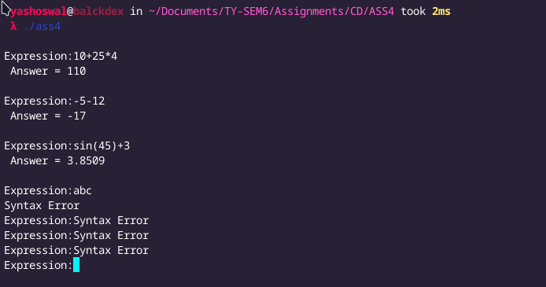

Code:

1. ass4.y

%{

#include <stdio.h>

#include <math.h>

%}

%union //to define possible symbol types

{double p;}

%token<p>num

%token SIN COS TAN LOG SQRT

%left '+''-' //lowest precedence

%left '\*''/' //highest precedence

%nonassoc uminu //no associativity

%type<p>exp //Sets the type for non-terminal

%%

/\*for storing the answer \*/

ss: exp {printf(" Answer = %g\n",$1);}

/\* for binary arithmatic operators \*/

exp: exp'+'exp { $$=$1+$3; }

|exp'-'exp { $$=$1-$3; }

|exp'\*'exp { $$=$1\*$3; }

|exp'/'exp {

if($3==0)

{

printf("Divide by Zero");

}

else $$=$1/$3;

}

|'-'exp {$$=-$2;}

|SIN'('exp')' {$$=sin($3);}

|COS'('exp')' {$$=cos($3);}

|TAN'('exp')' {$$=tan($3);}

|LOG'('exp')' {$$ =log($3);}

|SQRT'('exp')' {$$ =sqrt($3);}

|num;

|'('exp')' {$$=$2;}

%%

main()

{

do

{

printf("\nExpression:");

yyparse(); /\* Parse the sentence repeatedly until the i/p runs out \*/

}while(1);

}

yyerror(char \*s;) /\* to print error message when an error is parsing of i/p \*/

{

printf("Syntax Error");

}

1. ass4.l

%{

#include <math.h>

#include "y.tab.h"

%}

%%

[0-9]+|[0-9]\*\.[0-9]+ {

yylval.p = atof(yytext);

return num;

}

sin {return SIN;}

cos {return COS;}

tan {return TAN;}

log {return LOG;}

sqrt {return SQRT;}

[\t] ;

\n return 0;

. return yytext[0];

%%